Blue Light: An Overview of the Evidence of Damage-Causing Mechanisms in the Skin
Elisabeth Stevens

Introduction
Blue light was previously considered benign as compared to UV light. The line between the two is established by wavelength, but there may not be a sharp cut-off in terms of whether or not they contribute to damaging reactions in the skin. Blue light is radiated to us from the sun, smartphones, TVs, and tablets; and has been shown to cause oxidative stress on the skin. It is possible to approach formulations with blue light damage mitigation in mind.

Background
Figure 1 below shows the categories of light separated by wavelength. Within visible light, blue light is considered HEV (high energy visual) light and is within 400-500 nm. Figure 2 shows the difference in penetration into the skin by the different categories of light. As the wavelength increases, the deeper the light waves will reach. See Figure 2. The main source of blue light responsible for the highest exposure to HEV for most people will be the sun. Sunlight can deliver an irradiance of 10¹–10² mW/cm². A computer screen 18” away can deliver irradiance of 0.6 mW/cm². The Average American spent about 8.5 hours per day in front of a computer screen in 2009 per study by Nielsen-funded Council for Research Excellence (CRE) by Ball State University's Center for Media Design (CMD). With increasing use of tablets, smartphones, laptops, and LED lights, HEV exposure levels will also be on the rise. White LED light is a mixture of yellow and blue light, so it is still considered a source of HEV.
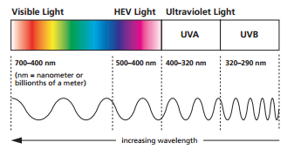
Figure 1. Categories of Light
https://www.visionease.com/coppertone-consumer/sunlight-your-eyes/

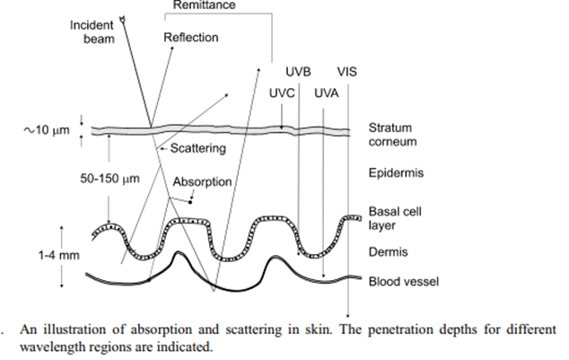
Figure 2. Penetration of Light into the skin (Moan 2001).
http://www.uio.no/studier/emner/matnat/fys/FYS3610/h06/undervisningsmateriale/Compendium/Moan7.pdf

Mechanisms of Damage
roGFP, or Redox-Sensitive Green Fluorescent Protein, can expressed in the mitochondria and cytosol of laboratory-bred mice. It is oxidized by glutathione disulfide, GSSG, and changes its absorption spectrum when oxidized. GSSG is the oxidized form of GSH, glutathione. The glutathione redox cascade is one of the body’s ways to protect against oxidative stress, and is triggered by superoxide and singlet oxygen species.
Mice in a study by Nakashima were exposed to UVA, blue light, green fluorescence, and even infrared. Absorption from roGFP was measured, and the measurement was used to estimate GSSG and GSH balance inside the cell, since the presence of oxidized roGFP will indicate the presence of GSSG. Human volunteers were exposed to blue light at levels same as direct sunlight, and fluorescence of GSSG was measured. They were exposed to 8 s of illumination at 460 nm and 13.8 mWcm⁻² every 10 s for 10 min, followed by an autofluorescence recording for 5 min without blue light illumination.
The oxidation events initiated by blue light mirrors the oxidation events by UVA light before tapering off after about 8 minutes of exposure. Here, it seems to level off at a ratio that favors oxidized roGFP in mitochondria, but does not quite reach the oxidation levels induced by UVA. See figure 3 below. This suggests that photolabile cells killed off at this level. Glutathione redox state was effective to protect against blue light damage in cytosol.
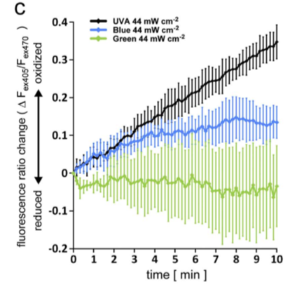
Figure 3. Comparison of ratios of oxidized roGFP produced by different wavelengths (Nakashima.). Absorption was measured, and measurement used to estimate GSSG and GSH balance inside the cell. Volunteers exposed to blue light at levels same as direct sunlight. 8 s of illumination at 460 nm and 13.8 mWcm⁻² every 10 s for 10 min, followed by autofluorescence recording for 5 min without blue light illumination.

In addition to the absorption measurements, Nakashima also noted that as melanin is an absorber of UVB and UVA light, it also absorbs light in the HEV category. It does not distinguish blue light as separate from UV light as it does for green and red light, which suggests a similar biochemical effect in the skin (Nakashima).
Oplander also did studies on blue light. Performed in vivo, the participants were radiated through a 10 x 15 cm window with wavelengths in the range of 420-834 nm, and intensities of 34 mWcm⁻². He found that local cutaneous blood flow was increased during exposure and up to five minutes following exposure. Further, blue light was able to form nonenzymatic nitric oxide, NO, in vivo by photolabile NO precursors such as S-nitrosothiol (RSNO) in skin tissues. See figure 4 below (Oplander).
Figure 4. Levels of nitric oxide from S-nitrosalbumin is shown. S-nitrousalbumin is a large component of S-nitrosothiol (Oplander)
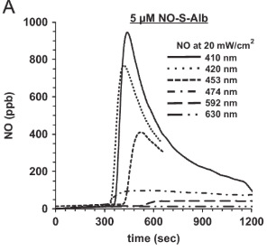

Liebmann performed blue light studies in vitro to endothelial cells as well as keratinocytes. Cells were radiated every 24 hours for 3 days. 24 hours after the last radiation, the number of viable cells were measured using staining methods. Light in the 412-426 nm range was found to be toxic to endothelial cells and keratinocytes at high fluences. See figure 5. These ranges would be approximately equivalent to conditions of natural sunlight. Up to a fluence of 500 mWcm⁻², light waves of 453 nm were nontoxic. Up to 453 nm, he found that light can release NO from nitrosinated proteins, but not from nitrite. This data suggests that protection from blue light may be desired.
For protection against HEV, Sodium Azide, but not Vitamin C, mitigated damages to endothelial cells when applied prior to exposure to blue light. Similar results were not found for keratinocytes (Liebmann).

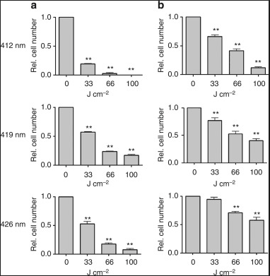
Figure 5. Viability of endothelial cells (column a) and keratinocytes (column b) after exposure to different wavelengths (Liebmann)

Summary
- Blue light is mainly delivered by sunlight, but increased use of smart devices as well as televisions can increase exposure.
- Blue light penetrates deeper into the skin than UV light.
- Blue light exposure results in oxidative stress in the skin.
- Blue light decreases viability of epithelial and keratinocytes.
- Formulation approaches may include sun protection under FDA sunscreen monograph and/or antioxidant ingredients with penetration enhancers, depending on the formulation and desired claims.

References
Lei, T. C., Pendyala, S., Scherrer, L., Li, B., Glazner, G. F., & Huang, Z. (2013, April 20). Optical profiles of cathode ray tube and liquid crystal display monitors: implication in cutaneous phototoxicity in photodynamic therapy. Retrieved April 01, 2018, from https://www.ncbi.nlm.nih.gov/pmc/articles/PMC5042687/
Liebmann, J., Born, M., & Kolb-Bachofen, V. (2010). Blue-Light Irradiation Regulates Proliferation and Differentiation in Human Skin Cells. Journal of Investigative Dermatology,130(1), 259-269. doi:10.1038/jid.2009.194
Moan, J. (2001) Visible light and UV radiation. In: Brune, D., Ed., Radiation at Home, Outdoors and in the Workplace; p. 69-85, Scandinavian Science Publisher.
Most detailed study yet of consumer video viewing suggests some rethinking is in order. (n.d.). Retrieved April 04, 2018, from http://cms.bsu.edu/news/articles/2009/3/mostdetailed-study-yet-of-consumer-video-viewing-suggests-some-rethinking-is-in-order
Nakashima, Y., Ohta, S., & Wolf, A. M. (2017). Blue light-induced oxidative stress in live skin. Free Radical Biology and Medicine,108, 300-310. doi:10.1016/j.freeradbiomed.2017.03.010
Opländer, C., Deck, A., Volkmar, C. M., Kirsch, M., Liebmann, J., Born, M., . . . Suschek, C. V. (2013). Mechanism and biological relevance of blue-light (420–453 nm)-induced nonenzymatic nitric oxide generation from photolabile nitric oxide derivates in human skin in vitro and in vivo. Free Radical Biology and Medicine,65, 1363-1377. doi:10.1016/j.freeradbiomed.2013.09.022

